

Routine Services Data, Reflect With Insight for RAMS interface Installation and User Guide

January 2015

Version 1.0



Contents

1.0 Introduction 3
2.0 Description of the project 3
3.0 Using the solution 3
3.1 Routine Services Data Asset Model 3
3.1.1 RSD 3
3.1.2 The Provider Domain 4
3.1.3 Child Assets 4
3.2 GIS Themes 7
3.3 RSD Reporting 7
3.3.4 Management Reports 7
3.3.5 3rd Party Service Provider Reports 8
3.4 RSD CSV Loader 9
3.4.6 CSV File Format 11
3.4.7 The tolerance domain 14
4.0 Installation and Removal 15
4.1 Installation 15
4.2 Removal 15
4.3 Post Installation Tasks 16
4.3.1 Custom GIS Themes for use in Spatial Manger 16
5.0 Summary and Conclusion 17

Introduction
The purpose of this document is to provide the New South Wales, Roads and Maritime Services (RMS) with support documentation for the Routine Services Data, Reflect with Insight for RAMS Interface project. This document is intended to explain how to install and use the various objects required in this project. This document does not attempt to describe what the objects should do. For that information see the current version of: “Reflect With Insight for RAMS interface Functional Specification” or “Reflect With Insight for RAMS interface Scope and Requirements.” This document should be read in its entirety prior to installing and running the objects related to the Routine Services Data, Reflect with Insight for RAMS Interface project.

Description of the project
Bentley Systems has developed a set of tools that utilizes both existing functionally and custom oracle objects to provide a solution to meet the requirements discussed in the Functional Specification documentation mentioned above. Various Oracle objects were created to support the CSV Loader and reporting aspects of the project.

Using the solution
This solution encompasses several items that are detailed below.

Routine Services Data Asset Model
The asset modeled needs to accommodate several types of Routine Services Data and allow the possibility of a one to many relationship. The Model functions like a typical Exor hierarchal Asset. The Use should rarely have to modify the data contained in this asset by hand as the data it typically handled by the CSV Loader aspect of the solution.

RSD
This is the top level Routine Services Data Asset and is used as the parent in a hierarchical asset set. This Level will hold things that are common to all the children and be associated with any location information for the Routine Services Data.

This asset contains the following attributes:

Attribute | Mandatory | Notes
Vendor Code | Y | Unique identifier representing the Service Provider. This list comes from the Domain “Provider”
Reference ID | Y | Unique number sent by the service providers to identify an activity information.
Road Number (Primary Location) | Y | Gazetted Road number. This is a 8 digit number and covers all the Motorways, State Roads and regional roads
Asset type code | Y | This is a unique identifier in RAMS to identify an asset type
Key-ID |  | Unique identifier in RAMS
Linear Reference Number |  | A number extracted from RAMS and provided to 3rd party service providers initially and periodically updated.
Asset description |  | This is the description of asset type in RAMS
Road Maintenance Segment |  | Each road that the RMS maintains (State roads) is divided up into manageable lengths. These manageable lengths are called road maintenance segments
Date of creation |  | Date the record is created initially
Time of creation |  | Time the record is created initially
Latitude | Y | Generated based on WGS84 datum and calculated to 5 decimal points
Longitude | Y | Generated based on WGS84 datum and calculated to 5 decimal points
Local Gov Area |  | LGA where the incident has occurred.

The data can be added or updated in RAMS using the user’s preferred Asset editing tool. Form NM0510 – Asset Items for Example.

The Provider Domain
To maintain a list of valid providers an Asset Domain named Provider has been created. To edit this domain form the Launchpad select asset manager > Asset Reference Data >Asset Domains (form NM301)
The value is the short code for the provider, this code is known to the provider and will be supplied by them in all data transferred to RMS. The meaning is the friend name for the provider that can be used in reporting.

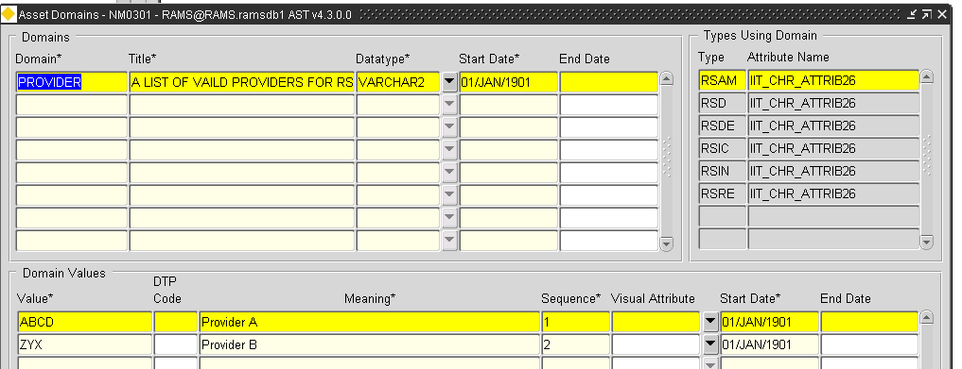

Child Assets
There are several Assets that are children for the RSS asset. They are for: Accomplishments, Defects, Incidents, Inspections and Requests. It is possible to have more than one child of the same type assigned to a parent asset. For example an RSD asset may have two or more accomplishments reported against it.

Accomplishments (RSAM)
The RSAM asset holds the information for the accomplishments recorded against the RSD asset. The attributes are as follows:

Attribute | Mandatory | Notes
Accomplishment Number | Y | This is the identifying number of the accomplishment visible to the user.
Accomplishment ID | Y | Unique number for accomplishment. Each service provider will be allocated a series of 10 million number to be used as Accomplishment ID.
Accomplishment Date |  | Date of completion of the task on a incident
Vendor Code | Y | Unique identifier representing the Service Provider.
Reference ID | Y | Unique number sent by the service providers to identify an activity information.
Activity | Y | Activity number as per M3 specification
Activity Name | Y | A description of the activity.
Activity Type | Y | Grouping of the related activities. For example Activity type 200 is Routine Pavement. It encompasses Pothole repair, Edge repair and similar activities.
Quantity Accomplished |  | Extent of work done to complete an activity. This is defined in terms of the unit of measurements defined for the activity in question.
Unit Of Measure |  | Unit of measurement defined for an activity, for example, meters, square meter.
Second Quantity |  | Different documents have defined the quantity in a different way. For example, the quantity could be in terms of length, area or volume. Second quantity is kept to accommodate the historical records.
Second Unit of Measure |  | Unit of measurement defined for an activity, for example, meters, square meter. This is separate from Unit of Measure to accommodate historical data.
Accomplishment Comments |  | Any additional information that is not covered in other fields
Time Work |  | Vendor provided total person hours for each activity completed
Completed (Yes/No) | Y | Status of an activity, This Attribute uses a domain which limits the responses to Y or N

Defects
The RSDE asset holds the information for the defects recorded against the RSD asset. The attributes are as follows:
Attribute | Mandatory | Notes
Vendor Code | Y | Unique identifier representing the Service Provider.
Reference ID | Y | Unique number sent by the service providers to identify an activity information.
Defect Number | Y | This is the identifying number of the defect visible to the user.
Defect ID | Y | Unique number for all Service provider for recording the defects reported.
Date Raised | Y | Date a defect was raised. Date Format - dd/mm/yyyy
Time Raised | Y | Time a defect was raised. Time Format - 13:00 hrs
Cause Of Defect | Y | The reason for the damage.
Reoccurring Defect (Yes/No) | Y | This is to identify find out the root cause of the problem. , This Attribute uses a domain which limits the responses to Y or N
Defect Type | Y | Define categories of defects with allocated number to each defect type
Position within Location |  | Shows the lane affected by Incident, Defect or Accomplishment.
Defect Completion Date |  | Date when a defect was fixed.  Format Mask: DD-MON-YYYY
Defect Completion Time |  | Time when a defect was fixed.  Format Mask: HH24:MI
Estimated Quantity for repair |  | Estimated extent of work to be performed to complete the repair. This is defined in terms of the unit of measurements defined for the activity in question.
Unit of Measure |  | Unit of measurement defined for an activity, for example, meters, square meter. This will be populated for accomplishment and defects.
Estimated Second Quantity |  | Different documents have defined the quantity in a different way. For example, the quantity could be in terms of length, area or volume. Second quantity is kept to accommodate the different specifications. This field is to cater for historical data on estimation.
Second Unit of Measure |  | Unit of measurement defined for an activity, for example, meters, square meter. This is separate from Unit of Measure to accommodate historical data.
Defect Comments |  | Additional information that is not covered in other fields.

Incidents
The RSIC asset holds the information for the Incidents recorded against the RSD asset. The attributes are as follows:
Attribute | Mandatory | Notes
Vendor Code | Y | Unique identifier representing the Service Provider.
Reference ID | Y | Unique number sent by the service providers to identify an activity information.
Incident ID | Y | Unique number for all Service provider for recording the incidents.
Incident Type | Y | Define categories of incident with allocated number to each incident type
Date Call Received | Y | Record the date of call received for the incident.  Format Mask: DD-MON-YYYY
Time Call Received | Y | Record the time of call received for the incident.  Format Mask: HH24:MI
Incident Description | Y | Textual description of the incident
Advice Received From |  | The person who reported the incident.
Condition At Time Of Incident |  | A list of conditions to be established and supplied to the service providers for dropdown list. Please see the maintenance specifications.
Action Required |  | What is the action required to handle the request.
Damage To Property | Y | Nature and extent of damage to RMS assets
Incident Completion Date | Y | The date of fixing the incident. Date  Format Mask: DD-MON-YYYY
Incident Completion Time | Y | Time of fixing the incident.  Format Mask: HH24:MI

Inspections
The RSIN asset holds the information for the Inspections recorded against the RSD asset. The attributes are as follows:
Attribute | Mandatory | Notes
Vendor Code | Y | Unique identifier representing the Service Provider.
Reference ID | Y | Unique number sent by the service providers to identify an activity information..
Inspection Number | Y | This is the identifying number of the inspection visible to the user.
Inspection ID | Y | Unique number for all Service provider for recording the inspections.
Inspection Type | Y | Define categories of inspection with allocated number to each inspection type
Target Date |  | Planned date for completion. Date  Format Mask: DD-MON-YYYY
Target Time |  | Planned time for completion.  Format Mask: HH24:MI
Inspection Completion Date | Y | Date of completion of the inspection.  Format Mask: DD-MON-YYYY
Inspection Completion Time | Y | Time of completion of the inspection.  Format Mask: HH24:MI
Inspection Comments |  | Additional information that is not covered in other fields.

Requests
The RSRE asset holds the information for the accomplishments recorded against the RSD asset. The attributes are as follows:
Attribute | Mandatory | Notes
Vendor Code | Y | Unique identifier representing the Service Provider.
Reference ID | Y | Unique number sent by the service providers to identify an activity information.
Request ID | Y | Unique number for all Service provider for recording the requests.
Request Type |  | Define categories of request with allocated number to each request type
Request Date Received | Y | Record the time of call received for the request.  Format Mask: DD-MON-YYYY
Request Time Received | Y | Record the time of call received for the request.  Format Mask: HH24:MI
Request Number | Y | This is the identifying number of the request visible to the user.
Request Completion Date | Y | Actual completion date of the request.  Format Mask: DD-MON-YYYY
Request Completion Time | Y | Actual completion time of the request.  Format Mask: HH24:MI
Request_Comments |  | Additional information that is not covered in other fields for the request received.

GIS Themes
Two types of GIS themes will be available for this asset. Standard RAMS asset themes and custom themes based on the reports listed in the report section. Those themes will be mentioned in the report section of this document. The standard asset themes can be accessed in the Exor Spatial Manager Tool and can be found in the location with the other asset themes.

Viewing the Standard Theme in Spatial Manager
The standard asset themes should automatically appear in the Asset Types tree of the Exor Groups tab of spatial manager.

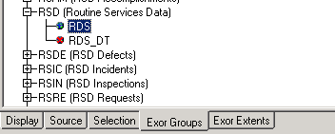

Right Click on the desired Asset and select display layer.

RSD Reporting
Several reporting objects are available for use with a report building tool. Some of the reports have a corresponding GIS version of them so that they can be used in Spatial Manager or another spatial tool of choice. The reports cover the following areas:

Management Reports
The management Reports are as follows:

Defect During a period
This reporting object is a standard oracle view with the name: x_rms_rsd_ddap. This view reports shows various defect information for a vendor. Several date fields are exposed that can be used to restrict that data over a selected period.
This report has a GIS counterpart with the name: x_rms_rsd_ddap_sdo. This counterpart view was designed to be viewed as a layer spatial manager.

Inspections During a period
This reporting object is a standard oracle view with the name: x_rms_rsd_idap. This view reports shows various inspection information for a vendor. Several date fields are exposed that can be used to restrict that data over a selected period.
This report has a GIS counterpart with the name x_rms_rsd_idap_sdo. This counterpart view was designed to be viewed as a layer spatial manager.

Requests during a period
This reporting object is a standard oracle view with the name: x_rms_rsd_rdap. This view reports shows various Requests information for a vendor. Several date fields are exposed that can be used to restrict that data over a selected period.
This report has a GIS counterpart with the name: x_rms_rsd_rdap_sdo. This counterpart view was designed to be viewed as a layer spatial manager.

Accomplishments during a period
This reporting object is a standard oracle view with the name: x_rms_rsd_adap. This view reports shows various Accomplishments information for a vendor. Several date fields are exposed that can be used to restrict that data over a selected period.
This report has a GIS counterpart with the name: x_rms_rsd_adap_sdo. This counterpart view was designed to be viewed as a layer spatial manager.

3rd Party Service Provider Reports
The Provider report is as follows:

Performance During A Selected Period
This reporting object is a non-standard oracle view with the name: x_rms_rsd_pdasp. This dashboard style report uses data from the Routine Services Data Defects section, the Requests section, the accomplishments section and the inspections section to determine several metrics.

To be able to achieve the dashboard like results a sys_context needed to be used. Before using this report the following commands should be issued form the report viewing software:
Note: MY_DATE is a text string in the format of ‘DD-MON-YYYY’ for example '01-JAN-1991'

XRMS_CONTEXT_RPT_DATES(‘START’, MY_DATE);
XRMS_CONTEXT_RPT_DATES(‘END’, MY_DATE);

If these context items are not set, then all the values are processed form '01-JAN-1901' to today.

Below is Sample data for a single provider:

Viewing the custom Report SDO Themes in Spatial Manager
This Assumes that the post installation steps outlined in: Custom GIS Themes for use in Spatial Manger, were completed.

To view the GIS themes for the custom reports. Open spatial manager and log on to RAMS via the Exor Menu. Open the Exor Groups Tab and scroll down to the section labeled: EXOR THEMES. Expand this selection and locate Asset Manager, now right click on the desired layer and select display layer.

RSD CSV Loader
Standard RAMS functionality is used with a customized procedure to load RSD asset and the child assets. This CSV loader can be accessed from form HIG1807 and is found in the launchpad under exor > CSV Loader CSV File Upload. Selecting this item will cause a browser window to open to the CSV File Upload - HIGWEB2030 web page. To load a single file select the file definition RSDCSV – Routine Services Data CSV Loader. Then Select “Load New Batch (Client)”. Then Select Continue.

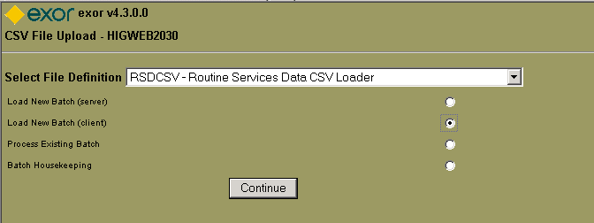

More Information about the option for the Loader webpage can be found in the Exor User Guide.

Use the browse button to select the file you wish to import, keep the process Method as Interactive and select Continue.
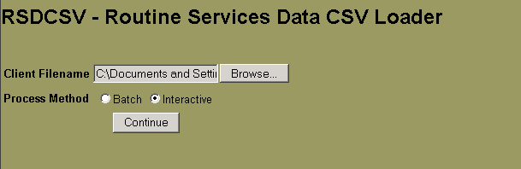

The next screen is informational press continue.

Now you will have a choice to Validate and the Load. The Custom procedure does validate during the Load process, so a separate validation may be skipped.

Select Load and leave the process method as interactive. Then Press Continue.

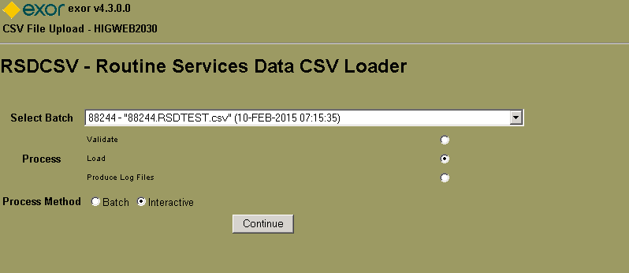

After some time to load the use is presented with an informational summary screen. This screen displays errors that may have occurred during the load:

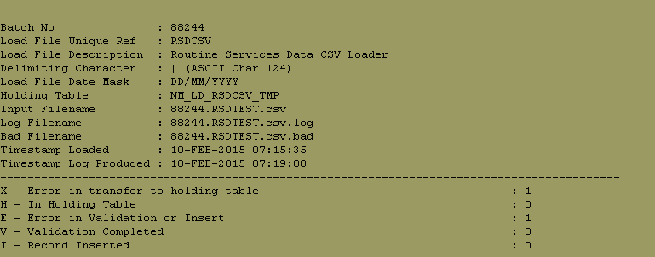
In this case there were 2 records that did not get inserted: 1 failed the initial load and one had an error during the load.
The error for the initial load reads: NET-0275: String length is invalid: 11 > 4:RSD_VENDOR_CODE and since it occurred in the first record and I had a head row in my CSV File I can ignore it.

The second error in this example read: RWI-0003: Incident Mandatory Column is null: RSIC_DATE_CALL_RECEIVED

This occurred because a mandatory child field was not supplied when a child ID was. In this case RSIC’s ID field was not null but the DATE_CALL_RECEIVED field did not have a value.

CSV File Format
The CSV loader is expecting the following field in a | (bar) separated file. Commas were not used as they may appear in comment fields.

The format for the Date fields are: DD/MM/YYYY
  - For example: 08/11/2013
- The time fields that immediately follow a Date field are identified as Varchar2 with a Size of 5. The expected format is: hh:mm
  - For example: 13:00

Column ID | Name | Related RSD Asset | Mandatory | Comments
1 | Vendor Code | RSD | Yes – For ALL
2 | Reference_id | RSD | Yes – For ALL
3 | Road_Number | RSD | Yes – For ALL
3 | Asset_type_code | RSD | Yes – For ALL
4 | Key_ID | RSD |  | Retrieved from RAMS Using other data if not supplied
5 | Asset_description | RSD |  | Retrieved from RAMS Using other data if not supplied
6 | Road_Maintenance_Segment | RSD | Yes - For All | Retrieved from RAMS Using other data if not supplied
7 | Date of creation | RSD | Yes - For All
8 | Time of creation | RSD |  | Omission will assume a default of 00:00h
9 | Longitude | RSD | Yes - For All
10 | Latitude | RSD | Yes - For All
11 | LGA | RSD |  | Retrieved from RAMS Using other data if not supplied
12 | Accomplishment_Number | RSAM | If Recording an Accomplishment
13 | Accomplishment_ID | RSAM | If Recording an Accomplishment
14 | Accomplishment_Date | RSAM | If Recording an Accomplishment
15 | Activity | RSAM | If Recording an Accomplishment
16 | Activity_Name | RSAM | If Recording an Accomplishment
17 | Activity_Type | RSAM | If Recording an Accomplishment
18 | Quantity_Accomplished | RSAM | If Recording an Accomplishment
19 | Unit_Of_Measure_RSAM | RSAM | If Recording an Accomplishment
20 | Second_Quantity | RSAM
21 | Second_Unit_of_Measure_RSAM | RSAM
22 | Accomplishment_Comments | RSAM | If Recording an Accomplishment
23 | Time_Work | RSAM | If Recording an Accomplishment
24 | Completed_(Yes/No) | RSAM | If Recording an Accomplishment | Y or N
25 | Defect_Number | RSDE | If Recording a Defect
26 | Defect_ID | RSDE | If Recording a Defect | Number or Varchar2
27 | Date_Raised | RSDE | If Recording a Defect
28 | Time_Raised | RSDE |  | Omission will assume a default of 00:00h
29 | Cause_Of_Defect | RSDE | If Recording a Defect
30 | Reoccurring_Defect_(Yes/No) | RSDE | If Recording a Defect | Y or N
31 | Defect_Type | RSDE | If Recording a Defect
32 | Position_within_Location | RSDE | If Recording a Defect
33 | Defect_Completion_Date | RSDE | If Recording a Defect
34 | Defect_Completion_Time | RSDE |  | Omission will assume a default of 00:00h
35 | Estimated_Quantity_for_repair | RSDE | If Recording a Defect
36 | Unit_of_Measure_RSDE | RSDE | If Recording a Defect
37 | Estimated_Second_Quantity | RSDE | If Recording a Defect
38 | Second_Unit_of_Measure_RSDE | RSDE | If Recording a Defect
39 | Defect_Comments | RSDE | If Recording a Defect
40 | Incident_ID | RSIC | If Recording an Incident
41 | Incident_Type | RSIC
42 | Date_Call_Received | RSIC | If Recording an Incident
43 | Time_Call_Received | RSIC |  | Omission will assume a default of 00:00h
44 | Incident_Description | RSIC | If Recording an Incident
45 | Advice_Received_From | RSIC
46 | Condition_At_Time_Of_Incident_ | RSIC
47 | Action_Required | RSIC
48 | Damage_To_Property | RSIC | If Recording an Incident
49 | Incident_Completion_Date | RSIC | If Recording an Incident
50 | Incident_Completion_Time | RSIC | If Recording an Incident | Omission will assume a default of 00:00h
51 | Inspection_Number | RSIN | If Recording an Inspection
52 | Inspection_ID | RSIN | If Recording an Inspection
53 | Inspection_Type | RSIN | If Recording an Inspection
54 | Target_Date | RSIN | If Recording an Inspection
55 | Target_Time | RSIN |  | Omission will assume a default of 00:00h
56 | Inspection_Completion_Date | RSIN | If Recording an Inspection
57 | Inspection_Completion_Time | RSIN |  | Omission will assume a default of 00:00h
58 | Inspection_Comments | RSIN | If Recording an Inspection
59 | Request_ID | RSRE | If Recording a Request
60 | Request_Type | RSRE
61 | Request_Date_Received | RSRE | If Recording a Request
62 | Request_Time_Received | RSRE | If Recording a Request | Omission will assume a default of 00:00h
63 | Request_Number | RSRE | If Recording a Request
64 | Request_Completion_Date | RSRE | If Recording a Request
65 | Request_Completion_Time | RSRE | If Recording a Request | Omission will assume a default of 00:00h
66 | Request_Comments | RSRE | If Recording a Request

The tolerance domain
In order to adjust the tolerance when the CSV Loader snaps to an existing RAMS Asset a Global Domain with the name: RWI_TOLERANCE has been created.

This Domain has a Value Named Default. The Default value is used to snap to an existing asset. Other values can also be created these values should match the names of an existing asset. The loader will look through this list and see if the asset in question is listed before using the default value.

This form can be opened from the Launchpad exor > reference data >Domains (Form HIG1807)
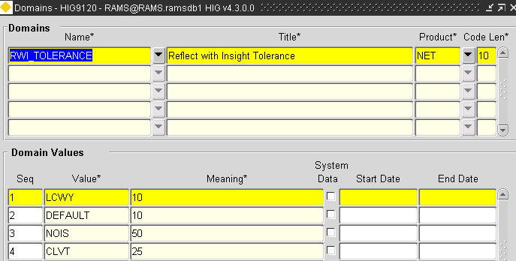

This shows a value for 3 assets: LCWY, NOIS and CLVT and the DEFAULT. The Meaning is in Metres.

Installation and Removal
After unpacking the installation package into it’s own directory. We recommend doing this in your exor\stage directory with a new directory created with the name RWI_RSD_CSV_Loader. The user will see the following directory structure:

- Meta
  - admin
  - docs
  - installs
- Views
  - sql
- CSV_Loader
  - admin
  - docs
  - installs

The Meta Directory contains Install and Uninstall Data for the RSD Meta model and its children.
The Views Directory contains the Install and Uninstall Data for the Reports and GIS Themes.
The CSV_Loader Directory contains the Install and Uninstall Data for the CSV Loader.

Installation

To Install the Meta model
From a command window go into the Meta installs directory. Start SQLPLUS as EXOR and use the command:
start install_RSD_assets.sql

To Install the Reports
From a command window go into the Views directory. Start SQLPLUS as EXOR and use the command:
start install.sql

To Install the CSV Loader
From a command window go into the CSV_Loader installs directory. Start SQLPLUS as EXOR and use the command:
start install_csv_loader.sql

Removal

To uninstall the CSV Loader
From a command window go into the CSV_Loader installs directory. Start SQLPLUS as EXOR and use the command:
start uninstall_csv_loader.sql

To uninstall the Reports
From a command window go into the Views directory. Start SQLPLUS as EXOR and use the command:
start uninstall.sql

To Install the Meta model
From a command window go into the Meta installs directory. Start SQLPLUS as EXOR and use the command:
start delete_asset_inv_items.sql
start Uninstall_RSD_assets.sql

Post Installation Tasks

Custom GIS Themes for use in Spatial Manger
After installing the views open the GIS Layer Tool in RAMS open form GIS0020, GIS Layer tool
- Select Custom Layers
- Select Register a Table As Theme
- Fill in the following:
  - Base Table: x_rms_rsd_adap_sdo
  - Primary Key Field: OBJECTID
  - Geometry Field: GEOLOC
  - Geometry Type: 3302
  - Theme Name: ACCOMPLISHMENTS_PERIOD
- Click Register
- 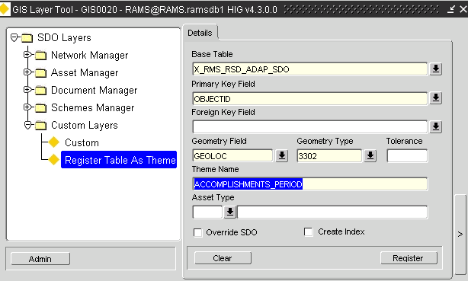
- Now Click on View Themes, this opens form GIS0010, GIS Themes
- Change the Product to AST
- Click on Roles
  - Add HIG_USER and Mode Normal
  - Others may be added if Roles are fine tuned
  - 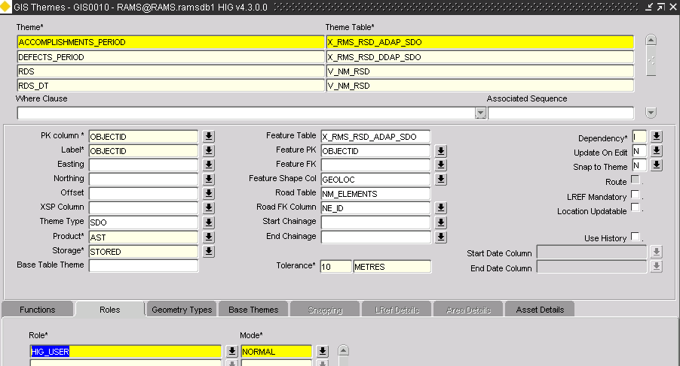
This Theme should now be available in Spatial Manager
Repeat the Process for:
- Defects during a period
- Inspections during a Period
- Requests during a period

Summary and Conclusion

The solution created by running the accompanying scripts will meet the needs outlined in the Reflect With Insight for RAMS interface Scope and Requirements and the Reflect With Insight for RAMS interface Functional Specification documentation.

